Step 0.

Install truffle if not installed already

Step 1.

Run command:

sudo npm install truffle -g

Step 2.

Open KYC-SC in terminal and execute command:

truffle init

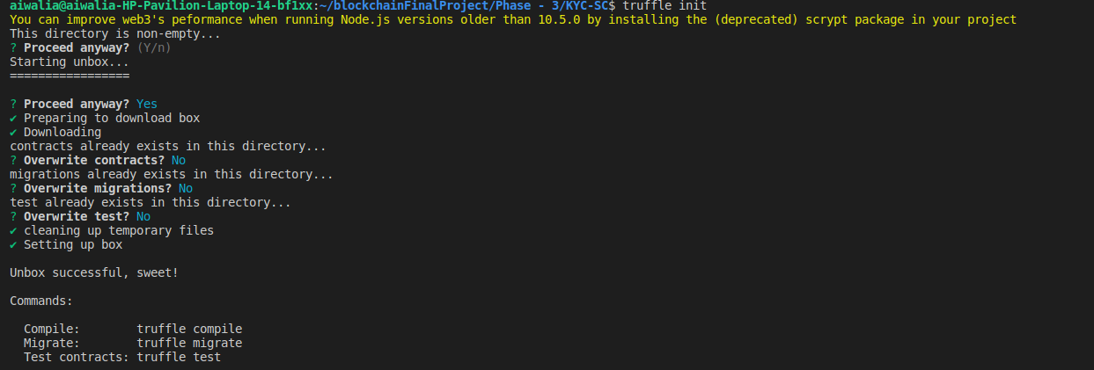

Select Y to Proceed anyway and select N for contracts,migrations and test.

Step 3.

Replace contents of truffle-config.js with contents of Truffle.js an save truffle-config.js file

Step 4.
Run command :

truffle compile

On successful compilation, you see logs as below image

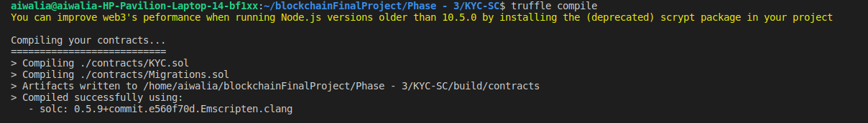

Step 5.

Open a new tab in Terminal and go to the directory, KYC-Blockchain and execute following command:

geth --datadir ./datadir init ./Init.json

You will see a datadir directory created under KYC-Blockchain

Step 6.
Execute the following command:

geth --datadir ./datadir --networkid 2019 --rpc --rpcport 30305 --allow-insecure-unlock console

This will open the geth console where we will create an account, unlock the account to deploy smart contract and start mining.

Step 7.

execute eth.accounts to check if there are some already existing accounts if the network was initiated from before.

Create a new account, pass password as the argument

personal.newAccount(‘finalproject’)

This will return the address of the account. This can be accessed in datadir/keystore too.

personal.unlockAccount('0x2807d3ef14015d2a101c47ed88d208f01d65c373','finalproject',0)

Step 8.

Open the other terminal(KYC-SC/truffle)

execute the following command:

truffle migrate --network geth

This will ensure that KYC.sol smart contract is compiled and executed.

Step 9.

To access the smart contract, open truffle console

truffle console --network geth

Step 10.

To access an instance of the deployed smart contract, execute

let kyc = await KYC.deployed()

and press enter

Step 11.

Now, when you use the following command :

kyc.

and press Tab twice you will see the various methods that are available to this instance of the smart contract.

